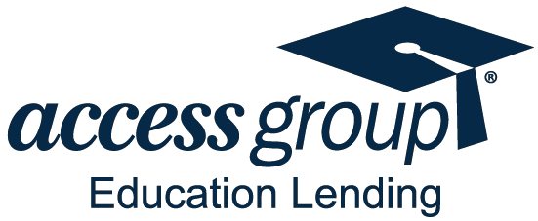

Rev. 11/2023

FACTS | WHAT DOES ACCESS GROUP DO  WITH YOUR PERSONAL INFORMATION?
Why? | Financial companies choose how they share your personal information. Federal law gives consumers the right to limit some but not all sharing. Federal law also requires us to tell you how we collect, share, and protect your personal information. Please read this notice carefully to understand what we do.
What? | The types of personal information we collect and share depend on the product or service you have with us. This information can include:  - Social Security Number and Employment Information  - Account Balances and Transaction History  - Payment History and Contact Information  When you are no longer our customer, we continue to share your information as described in this notice.
How? | All financial companies need to share customers’ personal information to run their everyday business. In the section below, we list the reasons ﬁnancial companies can share their customers’ personal information; the reasons Access Group chooses to share; and whether you can limit this sharing.
Reasons we can share your personal information |  |  | Does Access Group Education Lending share? | Can you limit this sharing?
For our everyday business purposes—  such as to process your transactions, maintain your account(s), respond to court orders and legal investigations, or report to credit bureaus |  |  | Yes | No
For our marketing purposes—  to offer our products and services to you |  |  | No | No; We don’t market (jointly or otherwise)
For joint marketing with other ﬁnancial companies |  |  | No | No; We don’t market (jointly or otherwise)
For our afﬁliates’ everyday business purposes—  information about your transactions and experiences |  |  | Yes | No
For our afﬁliates’ everyday business purposes—  information about your creditworthiness |  |  | No | No; We don’t share this information
For our afﬁliates to market to you |  |  | No | No; We don’t share (no marketing)
For nonafﬁliates to market to you |  |  | No | No; We don’t share (no marketing)
Questions? |  | Call 866-610-3660, visit www.accessgroup.org, or email general@accessgroup.org

Page 2
Who we are
Who is providing this notice? |  | This notice is provided by Access Group Education Lending and other affiliated companies such as financing trusts*.
What we do
How does Access Group Education Lending protect my personal information? |  | To protect your personal information from unauthorized access and use, we use security measures that comply with federal law. These measures include computer safeguards and secured ﬁles and buildings.
How does Access Group Education Lending collect my personal information? |  | We collect your personal information, for example, when you  - Give us your income information  - Give us your contact information  - Provide employment information  - Pay your bills  We also collect your personal information from others, such as credit bureaus, affiliates, or other companies.
Why can’t I limit all sharing? |  | Federal law gives you the right to limit only:  - sharing for afﬁliates’ everyday business purposes— information about your creditworthiness  - afﬁliates from using your information to market to you  - sharing for nonafﬁliates to market to you
Definitions
Afﬁliates |  | Companies related by common ownership or control. They can  be ﬁnancial and nonﬁnancial companies.  - Our afﬁliates include financial companies such as financing trusts*.
Nonafﬁliates |  | Companies not related by common ownership or control. They  can be ﬁnancial and nonﬁnancial companies.  - Access Group Education Lending does not share with nonafﬁliates so they can market to you.
Joint marketing |  | A formal agreement between nonafﬁliated ﬁnancial companies that together market ﬁnancial products or services to you.  - Access Group Education Lending doesn’t jointly market.
* Notice provided by: AccessLex Institute dba Access Group Education Lending and Access Group; Access Funding 2010-A LLC; Access Funding 2013-1 LLC, and Access Funding 2015-1 LLC.
Access Group Education Lending includes the following loans: Business Access®, Comprehensive Access®, Dental Access®, Graduate Access®, Health Access®, Law Access®, Medical Access®, Optimum Access®, and Sponsored Access®.

